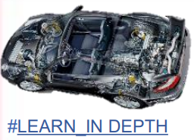**Ain Shams University**

**Faculty of Engineering**

**Mechatronics Engineering Department**

**Mastering Embedded System Online Diploma** [**www.learn-in-depth.com**](http://www.learn-in-depth.com)

**First Term (Final Project 2)**

**“Student Information Management System”**

**Eng. Omar Ahmed Dawood**

**My Profile: <** [oa0578222@gmail.com (learn-in-depth.com)](https://www.learn-in-depth.com/online-diploma/oa0578222%40gmail.com)**>**

Contents

**1** **Introduction** 3

1.1 Features of each Student 3

1.2 Features of All system 3

**2** **Implementation** 4

2.1 Add Student manually 4

2.2 Add students from file 5

2.3 Count of students 5

2.4 Find the student by the given Roll Number 6

2.5 Find the student by the given First Name 6

2.6 Find Students registered in a course 7

2.7 Show all Information of students 7

2.8 Delete a student 8

2.9 Update a student 9

**3** **Test Cases** 10

3.1 Add Students from File 10

3.2 Add student Manually 11

3.3 Find student by Roll Number 12

3.4 Find student by First Name 12

3.5 Find Students registered in a course 13

3.6 Count of students 13

3.7 Delete a student by Roll Number 14

3.8 Update a student 15

# **Introduction**

* In this project we will Implement Student Information Management System that it has many features to become easy for users.

## Features of each Student

* Store First Name of the student.
* Store Last Name of the student.
* Store Unique Roll Number of the student.
* Store GPA of the student.
* Store Courses ID of the student.

## Features of All system

* Add Student Details from File.
* Add Student manually.
* Find the student by the given Roll Number.
* Find the student by the given First Name.
* Find Students registered in a course.
* Count of students.
* Delete a student.
* Update a student.
* Show all Information of students.
* Exit from the system.

# **Implementation**

## Add Student manually

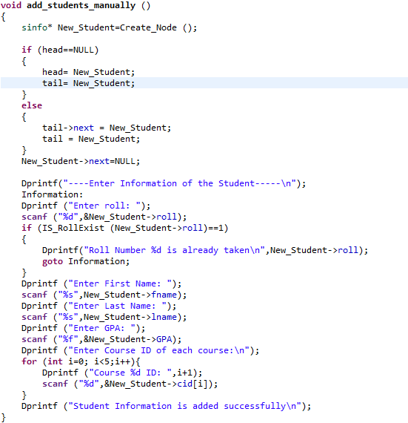

## Add students from file

## Count of students

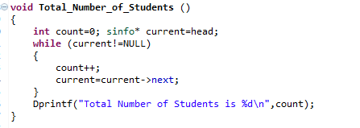

## Find the student by the given Roll Number

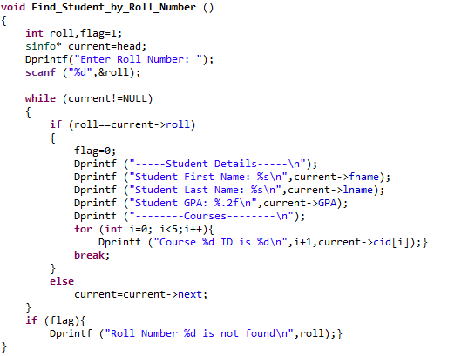

## Find the student by the given First Name

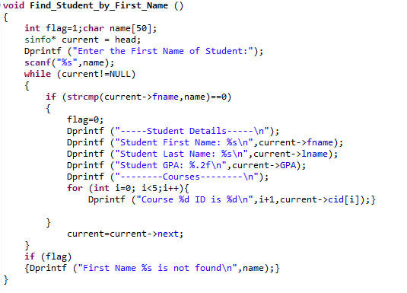

## Find Students registered in a course

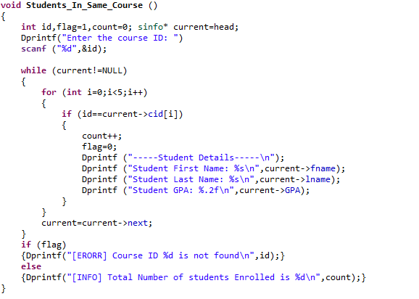

## Show all Information of students

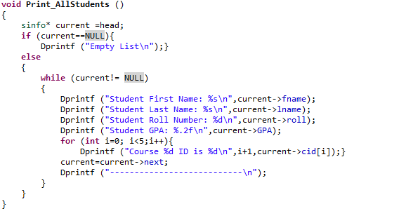

## Delete a student

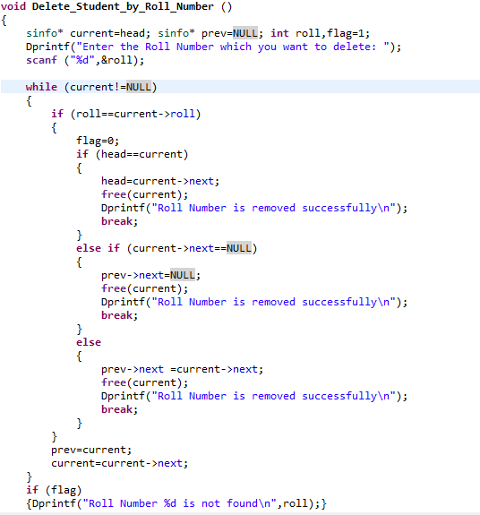

## Update a student

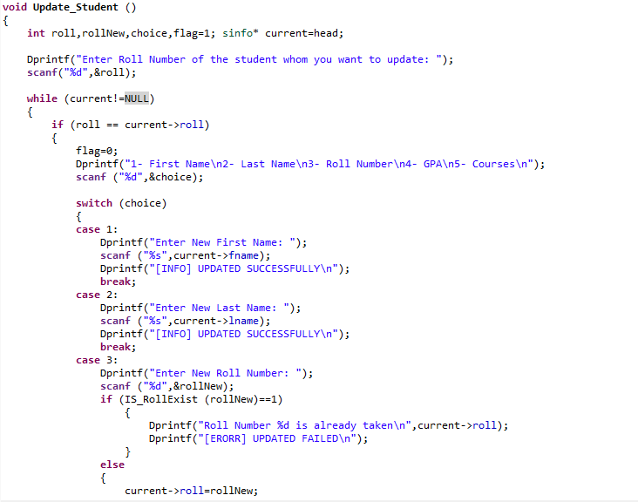

# **Test Cases**

## Add Students from File

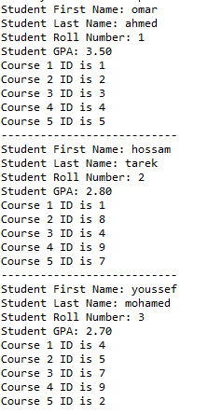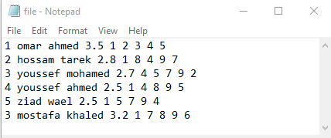

**File.txt**

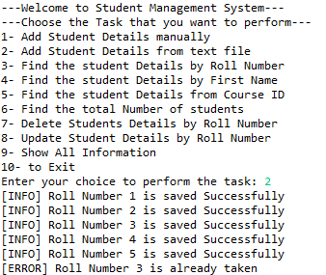

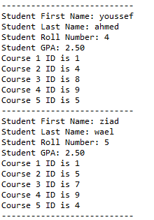

**Running**

**Students**

## Add student Manually

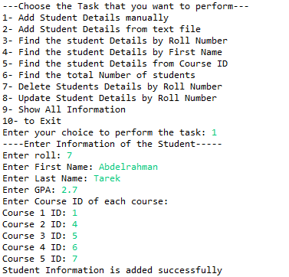

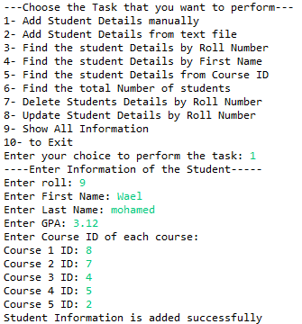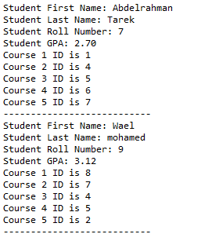

**Students**

## Find student by Roll Number

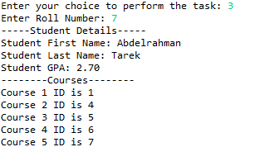



## Find student by First Name

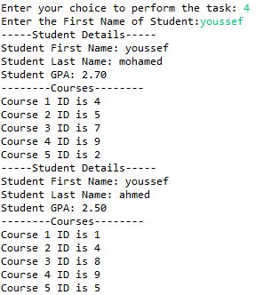



## Find Students registered in a course

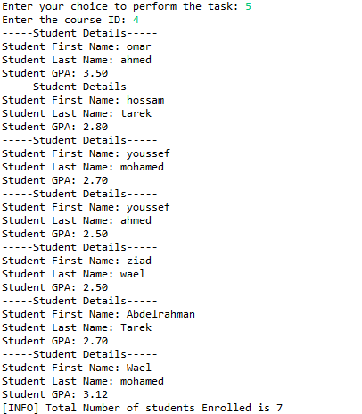



## Count of students



## Delete a student by Roll Number

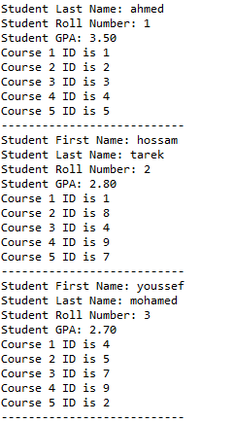





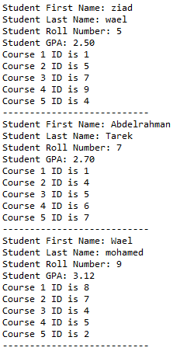

## Update a student

